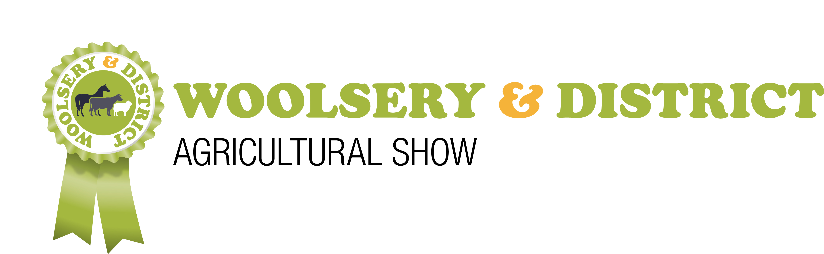 | ENTRY FORM - HORSES / PONIES  25th July 2022  You can also enter and pay on line www.woolseryshow.org.uk  Entries Close – 26th June 2022 - Late entries NOT accepted | Please complete a separate form for each owner

OFFICE USE | CLASS NO. | NAME OF HORSE/PONY | BREED | AGE | SEX  C,F,M,G,S | COLOUR | BREEDER | NAME OF RIDER/WHIP | Date of Birth if 17 and under | £ FEE
 |  | Reg. No.
 |  | Reg. No.
 |  | Reg. No.
 |  | Reg. No.
BACS Payments: Lloyds Bank Woolsery Show 30-90-89, 38643460 – use initial & surname for reference. Please tick  or by cheque to Woolsery & District Agricultural Show . Please tick  Entries to: B Butler, Harbour Lights, Horns Cross, Bideford, EX39 5DW – online will save postage! |  |  |  |  |  |  | COMPULSORY FIRST AID FEE |  |  | 3.00
 |  |  |  |  |  |  | ADDITIONAL ADULT PASSES @ £8.00 EACH
 |  |  |  |  |  |  | ADDITIONAL CHILD PASSES @ £3.00 EACH
Driving Competitors & Team Relay please give a brief description of vehicle and horses or team, horse and dog on the reverse of this form. Indicate any junior whips so appropriate rosettes are available. |  |  |  |  |  |  |  | TOTAL ENTRY FEE
Name of Owner
EXHIBITOR TICKETS Please note exhibitor passes will be issued on the following scale. Extra passes must be paid for.
1 animal 2 passes 1 lorry pass
2 animals 3 passes 1 lorry pass
3 animals 4 passes 1 lorry pass
4 animals 5 passes 1 lorry pass
Please ensure that all passes are displayed when entering the showground. If no passes are displayed the full entry price will be charged to all occupants.
Passes are for vehicles containing/towing horses/ponies ONLY.

Address

Postcode

Mobile Evening Tel. Email

I/WE DECLARE THAT ALL THE DETAILS ENTERED ON THIS FORM ARE CORRECT AND THAT THE ANIMALS ARE MY/OUR OWN. I/WE HAVE READ & AGREE TO ABIDE BY THE RULES, CONDITIONS & RESPONSIBILITIES IN THE WOOLSERY SHOW SCHEDULE.

Signature_________________________________________________________ Date _______________________

DISTRICT: Hartland, Parkham, Clovelly, Alwington, Bulkworthy, Buckland Brewer, East & West Putford, Woolsery, Bradworthy, Welcombe, Abbotsham, Littleham, Sutcombe, Newton St Petrock & Abbots Bickington. Are you eligible for the District Classes & Award? Please tick
Data Protection It is a condition of entry that Woolsery & District Agricultural Show reserves the right to provide Exhibitor information to relevant regulatory authorities e.g. Defra, APHA, Trading Standards and other agencies if requested. Relevant details will also be published in the Show Catalogue and sent to the press (unless you advise the Secretary in writing) . Personal Data will be retained electronically in secure systems by Woolsery & District Agricultural Show so that show schedules can be sent by email or post to Exhibitors in future years. Woolsery & District Agricultural Show is committed to protecting Exhibitor information and using it responsibly. Please read our Privacy Policy to understand how we collect, use and store your information.

OFFICE USE | CLASS NO. | NAME OF HORSE/PONY | BREED | AGE | SEX  C,F,M,G,S | COLOUR | BREEDER | NAME OF RIDER/WHIP | Date of Birth if 17 and under | £ FEE
 |  | Reg. No.
 |  | Reg. No.
 |  | Reg. No.
 |  | Reg. No.
 |  | Reg. No.
 |  | Reg. No.
 |  | Reg. No.
Please continue over-leaf if more space needed  BACS Payments: Lloyds Bank Woolsery Show 30-90-89, 38643460 – use initial & surname for reference. Please tick or by cheque to Woolsery & District Agricultural Show . Please tick  Entries to: B Butler, Harbour Lights, Horns Cross, Bideford, EX39 5DW – online will save postage! |  |  |  |  |  |  | COMPULSORY FIRST AID FEE |  |  | 3.00
 |  |  |  |  |  |  | ADDITIONAL ADULT PASSES @ £8.00 EACH
 |  |  |  |  |  |  | ADDITIONAL CHILD PASSES @ £3.00 EACH
 |  |  |  |  |  |  |  | TOTAL ENTRY FEE

