CLOVELLY COURT EX39 5SY
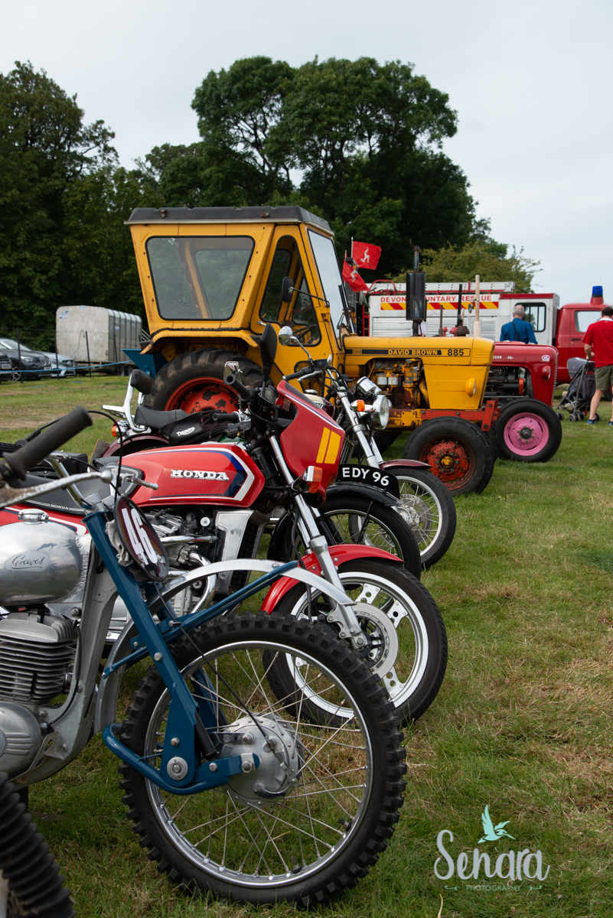 | Vintage Tractor, Machinery Display & Parade  Monday  27th July 2020  Contact Bonham Jewell  On 01237 431600  Or www.woolseryshow.org.uk  *Entry and risk assessment form, copy of insurance liability cover compulsory.  *Exhibitors must arrive by 09.00 and not leave until after the Vintage Parade.
Entry passes, 1 per small vintage item/motorbike or 2 for large vintage vehichle e.g. tractor will be sent 7-10 days before the show. We provide a pasty & cup of tea for each vintage entry ticket holder.

